**Business Requirements Document**

**Customer: Microsoft**

**Domain: beam.pro**

**Business Requirement 1 : General Functionality**

1.0 Company Logo visible on main route https://beam.pro/

2.0 Verify company title visible on page.

3.0 To successfully login to an account a valid email and password must be entered.

4.0 User name will be the users e-mail e.g. "username@yourdomain.com".

5.0 The password will contain between 8 and 12 alpha and numeric characters with one alpha character being a capital

6.0 There will be an option for user to reset password if it is forgotten

6.1 Details of new login ID’s emailed to client

6.2 Rese

**Business Requirement 2 : Signup / Login (Authentication)**

1.0 Verify an option to view the Login in segment is visible when clicking the Sign Up button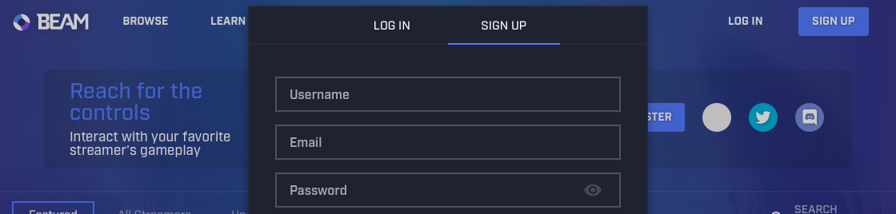

2.0 Verify 3 alternative methods of signup are available through Social Sign ins. The 3 providers should be : Microsoft Twitter and Discord.

3.0 User name will be a personally chosen handle. There are no restrictions other than uniqueness. Username field should display a message when chosen handle is not unique.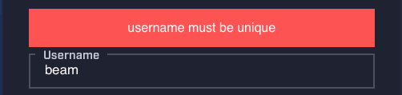

4.0 A valid email string is required in the ‘Email’ field.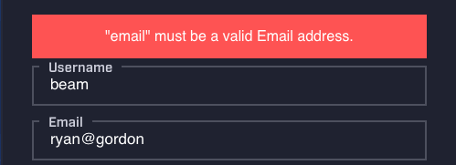

5.0 The password will be required to be at least 4 characters long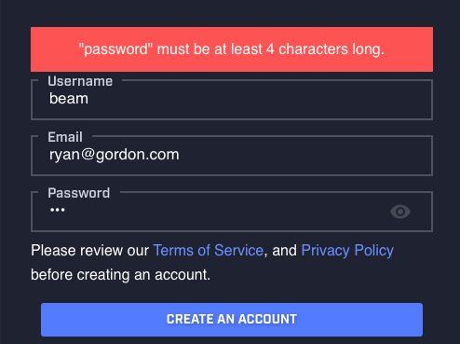

6.0 User will be required to confirm an account upon sign up.